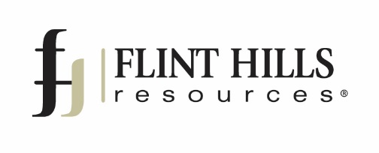

News Release
__________________________________________________________________________

July 24, 2017 Contact: Chris Duffy
duffy@goffpublic.com
612-599-7982

Flint Hills Resources’ Pine Bend Refinery
Wins Two Awards for Rail Safety

Rosemount, Minn. – Flint Hills Resources’ Pine Bend refinery recently received two awards for strong rail safety performance in 2016. These recognitions include the Chemical Safety Excellence Award from CSX Corporation and the Thoroughbred Chemical Safety Award from Norfolk Southern Corporation.

“There is no higher praise to our operations than winning a safety award,” said Geoff Glasrud, vice president and manufacturing manager of Flint Hills Resources Pine Bend. “Safety is at the core of everything we do at Pine Bend, and it is an honor to receive these two prestigious awards that recognize our commitment to keeping our employees, contractors and community safe.”

The Flint Hills Resources Pine Bend refinery is widely recognized as one of the safest refineries operating in the United States. In 2016, the refinery was recognized by the Association of American Railroads as an exemplary shipper, and in 2014 Pine Bend became the first facility in the country to be certified as a PRO-10 worksite. The refinery received the Governor’s Safety Award from the Minnesota Safety Council for the sixth time in 2014 and was recertified as a Minnesota STAR worksite through 2018 in 2013.

Chemical Safety Excellence Award from CSX Corporation
Based in Florida, CSX is a transportation and real estate corporation responsible for 21,000 route miles of railroad in the United States. Their Chemical Safety Excellence Award annually recognizes customers for their commitment to safe procedures, such as securing valves and closures properly and safe loading. To be eligible, a company must ship more than 600 carloads of product during the year without an incident due to controllable factors.

Thoroughbred Chemical Safety Award from Norfolk Southern Corporation
Norfolk Southern is a transportation corporation headquartered in Virginia that operates nearly 20,000 route miles of railroad in the United States. Recipients of their Thoroughbred Chemical Safety Award must ship at least 1,000 carloads of product on the rail network that year without a single incident.
About Flint Hills Resources
Flint Hills Resources Pine Bend refinery produces transportation fuels used throughout the Midwest, including most of Minnesota’s gasoline, diesel fuel, jet fuel, as well as other products people rely on such as propane and asphalt. Located 17 miles southeast of Minneapolis, Pine Bend has a capacity of 339,000 barrels per day and is among the cleanest, most efficient, and safest oil refineries in the country. Flint Hills Resources directly and indirectly supports more than 4,000 Minnesota jobs and has invested nearly $1.7 billion on upgrades and improvements to its Minnesota facilities since 2010. With 1,300 full-time employees, the Flint Hills Resources Pine Bend refinery is one of the largest employers in Dakota County. More information about the company is available at pinebendrefinery.com.

###

